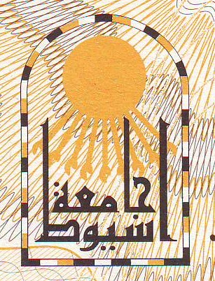
Faculty of Medicine
Employee Affairs
STATE OF EMPLOYEMENT
Date: 23rd October 2013
Personal Information
Name: Ragai Sobhi Ibrahim Sobhi Hanna
Date of Birth: 10th August 1971 Place of Birth: Assiut, EGYPT
Marital Status: Married Religious: Christian
Nationality: Egyptian Military Service: Finally Exempted
Institution: Surgery Department, Faculty of Medicine, Assiut University, EGYPT.
Current Job: Lecturer of Surgery since 31st March 2013.
Qualifications:
- MBBcH, 1995, Very Good with Honor, Assiut University.
- Master Degree in Surgery, 1999, Good, Assiut University.
- Master Degree in Neurosurgery, 2011, Very Good, Assiut University.
- Doctorate Degree in Surgery, 2008, Ain Shams University.
Job Progress:
- House Officer in Assiut University Hospitals, Start Date 01/03/1996.
- Resident Doctor in Surgery Department, Assiut University Hospitals, Start Date: 08/03/1997.
- Assistant Lecturer in Neurosurgery Department, Faculty of Medicine, Assiut University, Start Date: 18/06/2001.
- Lecturer in Surgery Department, Faculty of Medicine, Assiut University, Start Date: 31/03/2013 to date.
These data has given upon his request to be submitted for the British Embassy in Cairo.
Administrator of Employee Affairs Dean

Stamp of Institution

